**COS10009/COS60006 Test 2 - 2020 S1**

**Assessment Details**

* **Assessment**: Test 2 – Sem 1 2020 V1
* **Unit Codes**: COS10009 / COS60006
* **Duration**: 2 hours in total. 90 minutes to complete, 30 minutes to submit.

## Student Name: Terry Lay

Student ID: 1742434

**Instructions to Candidates**

* **You must complete all the questions.**
* You must submit this test booklet to Doubtfire within 2 hours of the test becoming available.
* The test answers must be your own work. By submitting your answers to Doubtfire you are declaring the work as your own.

# Section 1. Coding - Answer the following questions:

**Q1.1)** Write code using a **while** **loop** in the Ruby programming language that will **print out** the 5 times table. The output should look as follows:

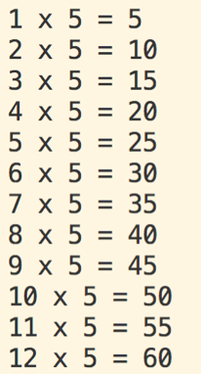

Write your Ruby code here:

def multi

i = 1

while i < 13

j = i * 5

puts i.to_s + " * 5 = " + j.to_s

i += 1

end

end

multi()

**Q1.2)** Write a Ruby function that takes two **integer arguments**, and **returns** the **difference** between the value of both arguments.

Write your function here:

puts "Please enter your first number: "

a = gets.to_i

puts "Please enter your second number: "

b = gets.to_i

def diff(a, b)

if a > b

c = a - b

else

c = b - a

end

return c

end

c = diff(a, b)

def print(c)

puts “The difference is: “ + c.to_s

end

print(c)

**Q1.3)** The following ‘Code to Be Corrected’ generates an error as indicated below. The expected output is also provided.

Indicate the incorrect line(s) of code and write replacement line(s) of code in the box provided under the code below. In your answer only write lines that need to be changed to correct the program.

**Expected output**:

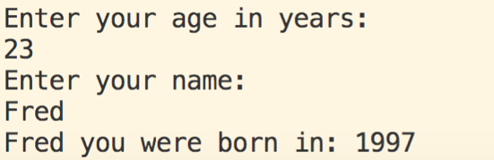

**Actual output**:

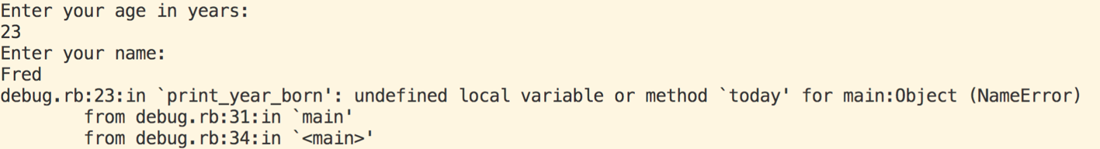

Code to be corrected:

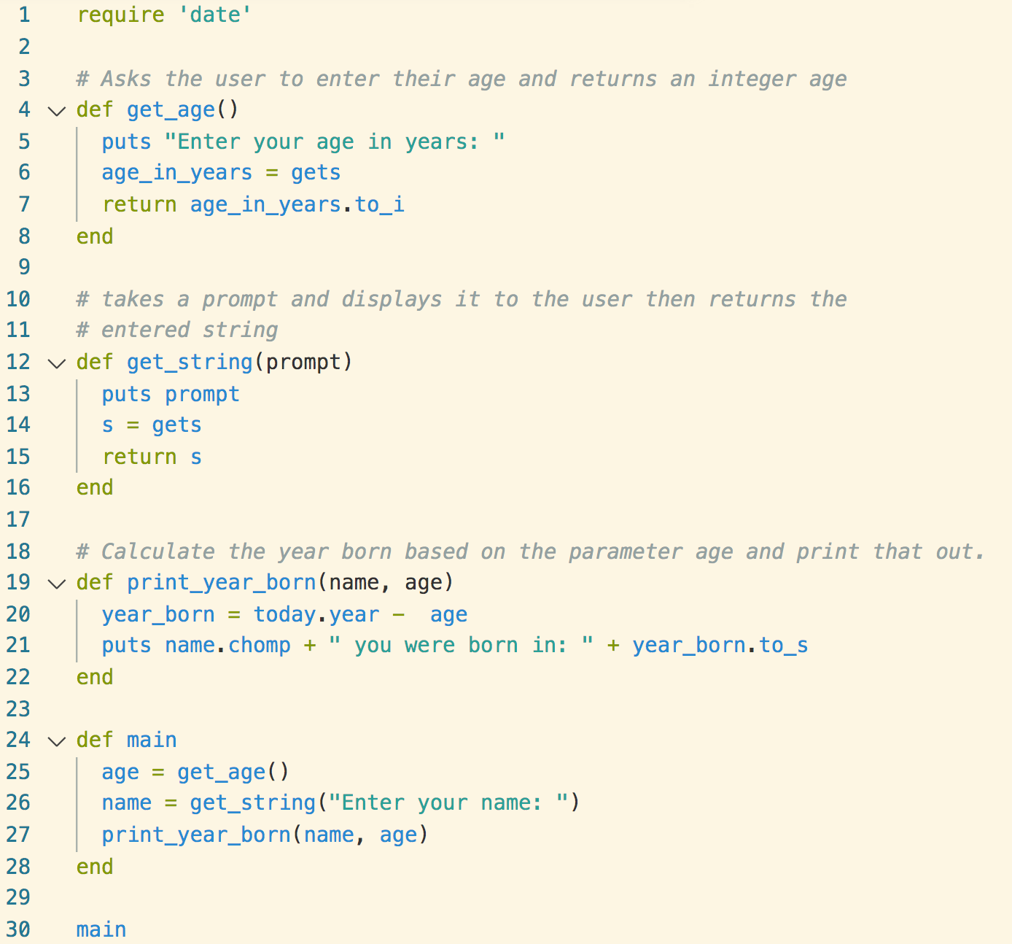

Write your corrected line(s) of code here (put the line number to indicate which line):

Line 20: year_born = Date.today.year - age

**Q1.4) Arrays.**

Complete the following code so that it prints out the array correctly. The output should look as follows:

|  |
| --- |
| Fido  Rex  Mandy  Bitza  Gypsy  Bluey |

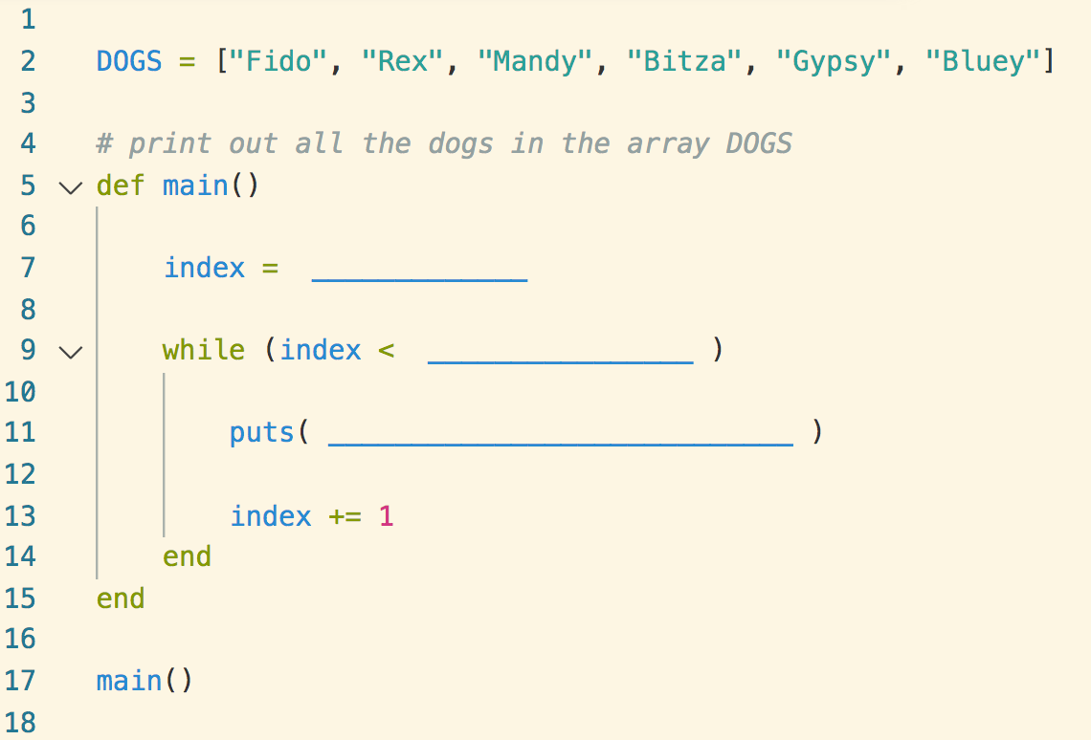

Write the missing sections for each line out here:

Line 7: index = 0

Line 9: while index < DOGS.length

Line 11: puts (DOGS[index])

# Section 2: Theory Questions

# (select the boxes or indicate your answer by highlighting or an X)

# Q2.1)

# 

# True

# False

# Q2.2) Write under each of the following sentences which of the terms listed best matched the sentence:

# Type, Statement, Keyword, Evaluation, Assignment, Operator,

# a syntactic unit of an imperative programming language that expresses some action to be carried out.

# Statement

# a symbol that tells the compiler or interpreter to perform specific mathematical, relational or logical operation and produce a final result.

# Operator

# determines the format in which data is stored.

# Type

# Q2.3)

# 

# True

# False

# Q2.4)

# 

# In Ruby we can represent complex types using classes

# In Ruby we can represent complex types using structs

# In Ruby we can represent custom types using modules

# In Ruby complex types can be components of other complex types

# Once you define a type you can assign values to the fields

# End of Task

# Submit your completed answer sheet to Doubtfire Task 10T within

# 2 hours of the test starting.